**Technical Test**

**Android Developer | Web Developer**

**Muhammad Ikram**

[**ikramkalsel@gmail.com**](mailto:ikramkalsel@gmail.com) **| +628 1352 5570 69**

1. **Bagian Satu**
2. Berikut source code dan outputnya
3. Terdapat besaran angka: 7.875.000 Berikan outputnya berupa:
   * + 7000000
     + 800000
     + 70000
     + 5000

* **Script**

|  |
| --- |
| <?php  $value = "7.875.000";  $value = str_replace(".", "", $value);  $arr = str_split($value);  $result = [];  foreach ($arr as $idx => $item) {  if ($item == "0") continue;  array_push($result, str_pad($item, count($arr) - $idx, "0") . "<br>");  }  foreach($result as $array){  echo $array;  }  ?> |

* **Output**

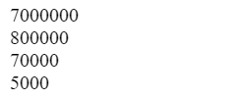

1. Tampilkan kata "Lima" pada saat perulangan menemukan angka 5 dengan rentang angka 1 s/d 10.

* **Source code**

|  |
| --- |
| <?php  function KataLima() {  for ($i = 1; $i <= 10; $i++) {  if ($i == 5) {  echo "Lima<br>";  } else {  echo $i . "<br>";  }  }  }  KataLima();  ?> |

* **Output**

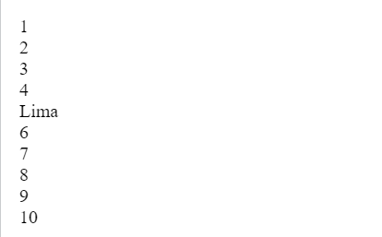

1. Output yang di hasilkan dari source code berikut
2. **Soal A**

|  |
| --- |
| <?php  $angka = 20;  $multiply = 2;  function hitung($angka){  $multiply = 3;  return (2*$angka);  $multiply = 2;  }  echo hitung(10);  echo hitung(100);  ?> |

Maka hasil Outputnya adalah **20200 atau 20 untuk hitung(10) dan 200 untuk hitung(100)**

1. **Soal B**

|  |
| --- |
| <?php  $a = 2;  function foo(){  $a = 3;  }  foo(); echo $a;  ?> |

Maka hasil Outputnya adalah **2**

1. Dari schema tabel dibawah, buatlah script untuk mendapatkan data dengan ketentuan:
2. Dapatkan data dengan kolom:

* order_items.order_id
* order_items.quantity
* order_items.product_id
* products.name
* products.merchant_name **(berdasarkan scema table terdapat peruabahan yaitu bukan products.merchant_name melainkan merchant.merchant_name)**
* users.full_name
* **Query**

|  |
| --- |
| SELECT order_items.order_id,  order_items.quantity,  order_items.product_id,  products.name,  merchant.merchant_name,  users.full_name  FROM `order_items`  INNER JOIN products ON products.product_id = order_items.product_id  INNER JOIN users ON users.user_id = order_items.user_id  INNER JOIN merchant ON merchant.id = products.merchant_id  WHERE order_items.product_id = products.product_id  AND order_items.user_id = users.user_id  AND products.merchant_id = merchant.id; |

* **Output**

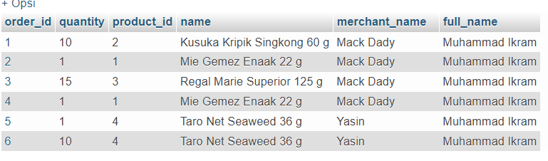

1. Dengan kondisi:
2. status pesanan sudah terbayar

* **Query**

|  |
| --- |
| SELECT order_items.order_id,  order_items.quantity,  order_items.product_id,  products.name,  merchant.merchant_name,  users.full_name,  master_status.name AS status  FROM order_status  INNER JOIN order_items ON order_items.order_id = order_status.order_id  INNER JOIN products ON products.product_id = order_items.product_id  INNER JOIN merchant ON merchant.id = products.merchant_id  INNER JOIN users ON users.user_id = order_items.user_id  INNER JOIN master_status ON master_status.id = order_status.status_id  WHERE order_status.order_id = order_items.order_id  AND products.product_id = order_items.product_id  AND users.user_id = order_items.user_id  AND master_status.id = order_status.status_id  AND master_status.name = "paid off"; |

* **Output**

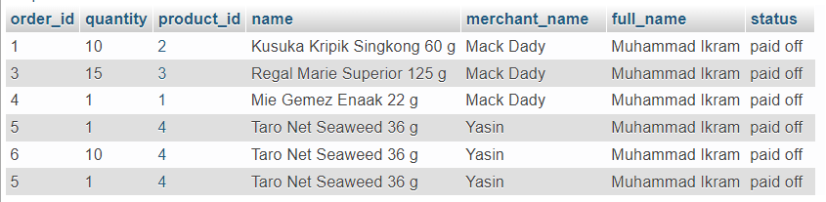

1. harga produk dikalikan quantity lebih besar dari 5000

* **Query**

|  |
| --- |
| SELECT order_items.order_id,  order_items.quantity,  order_items.product_id,  products.name,  merchant.merchant_name,  users.full_name,  (products.price * order_items.quantity)AS total  FROM order_items  INNER JOIN products ON products.product_id = order_items.product_id  INNER JOIN merchant ON merchant.id = products.merchant_id  INNER JOIN users ON users.user_id = order_items.user_id  WHERE products.product_id = order_items.product_id  AND users.user_id = order_items.user_id  AND (products.price * order_items.quantity)>5000 |

* **Output**

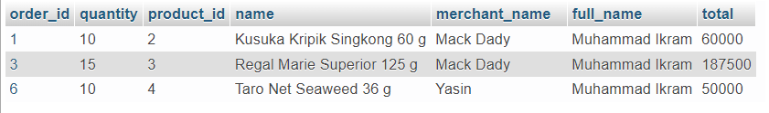

1. 4 huruf akhir merchant_name adalah "DADY"

* **Query**

|  |
| --- |
| SELECT order_items.order_id,  order_items.quantity,  order_items.product_id,  products.name,  merchant.merchant_name,  users.full_name  FROM order_items  INNER JOIN products ON products.product_id = order_items.product_id  INNER JOIN merchant ON merchant.id = products.merchant_id  INNER JOIN users ON users.user_id = order_items.user_id  WHERE products.product_id = order_items.product_id  AND users.user_id = order_items.user_id  AND RIGHT(merchant_name, 4) = 'DADY'; |

* **Output**

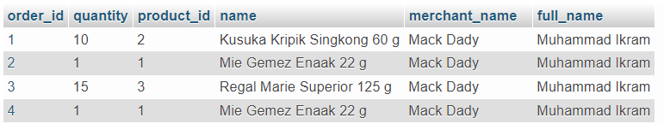

1. periode merchant akan expired pada tanggal 01-Jan-2022

* **Query**

|  |
| --- |
| SELECT * FROM `merchant` WHERE merchant.expired_date = "2022-01-01" |

* **Output**

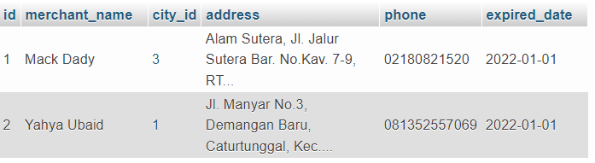

1. nama kota dengan kondisi like dengan mencari bagian dari kata (dihimpit huruf lain di depan dan belakang) sama dengan "ONE"

* **Query**

|  |
| --- |
| SELECT * FROM `city` WHERE city.name LIKE "%ONE%" |

* **Output**

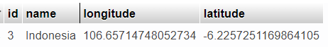

1. **Bagian Dua**